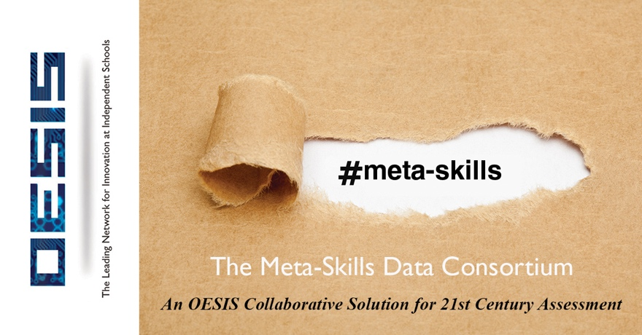

An Invitation to OESIS Network Schools to Participate
Membership Cost Phase 1: $2,500
Launch: 2018-2019 School Year

Vision & Overview

This is a teacher leadership project that in phases will build from the ground up a solution to the needs we have as a community (a) to define a range of meta-skills and competencies, (b) to determine strategies for validating their progression and (c) to provide educators with teacher-designed data tools. Meta-skills are the sub-skills that indicate performance towards a higher competency such as Critical Thinking or Creativity: an example under Critical Thinking might be “asks follow-up questions in the historical period covered to broaden his/her inquiry”.

Phase 1: 12 months

In Phase 1, we plan to build 4 large working groups of teachers in grades 5-8 and a Senior Working Group to coordinate the work of the Grade Level Leadership Groups using 50% of the membership fees to offer Teacher Leadership grants to these participating teachers and administrators. The deliverable in Phase 1 will be a Report based on deep research grade by grade on the likely range of meta-skills, competencies and standards that are or will be targeted by schools and meaningful information alongside them in terms of drivers. Such a schema is not attempting to prescribe a framework but to provide a schematic range which can help schools determine what they might use themselves. This report will help assess the degree of variance in skills, strategies and learning objectives being targeted by schools. It should provide a significant platform for curricular and pedagogical analysis.

Phase 2:

In Phase 2, the Grade Level Leadership Groups will be refreshed and move onto a secondary task that will be to determine strategies for building standards of assessment of these skills. This might include formulating a networking and peer review type Program similar to the AP reader programs. It would examine the possibilities of building a data application that can capture proficiency data at the granular skill level. The groups will consider for the data application, the kinds of information that might be necessary at the educator level so that effective intervention and curricular/pedagogical recalibration can take place: examples of such characteristics might include rubric type, formative assessment frequency, correlations with summative endpoints, equity enabling markers that could be identified in anonymous profiles to determine invisible barriers etc.

Phase 3: Data Application Build out
Once we have determined how to correlate data in different forms and the underlying standards behind meta-skill assessment, we can move on to this stage. It is likely that membership in the data application phase will be differentiated according to what is being provided by schools: so schools providing no data at all may not be invited to participate or might be paying a significantly higher price. These and other kinds of participation issues will be decided at the time by the Senior Working Group. We have already made it clear that this application like most tech tools or data solutions will not work without a teacher-designed network effect and OESIS intends to make sure this will be the focus (per the Foundational Principles set out below). The data produced in the application will also not be able to identify a school by name nor a student by name nor a teacher by name.

Foundational Principles

- We believe that skills analysis will be subject to either inflation or lack of substantiation and that this is not a risk schools can afford when they are in the business of producing authentic feedback that can modify behavior and produce growth.

- We believe that data usage at independent schools have been stymied by a lack of teacher buy-in and fear that they represent flawed accountability strategies. We therefore think it a sine qua non of success that the data approach be teacher-designed and teacher networked for ongoing validity.

- We believe that data affords a key tool in providing student equity and breaking down invisible barriers of age, gender, race, learning differences and more.

- We believe that the 21st Century requires all citizens to live and thrive in a world where better decisions and choices are enabled by data.

Budget

This consortium will be coordinated by OESIS Group as a non-profit project in the first two research phases with a Senior Working Group approving expenditures. Half of the budget will go to the Grade Level Leadership Groups with the other half going for building research tools, consultants, compensation for the time of the senior working group, travel and marketing: we have reached out to organizations like the Great Schools Partnership and research consultants in the competency based data space who are keen to help us. Once we move towards a data application build-out the Senior Working Group will consider partners who can fund the cost and the membership fees that will be required to support its maintenance and ancillary support activities: we already have good visibility how we can get this piece funded but Phases 1 & 2 are essential pre-requisites.

Teacher Leadership Grants & Expectations

We will open a submission process in mid June for teachers who wish to participate in one of the 4 Grade Level Leadership Groups. Each Group will have two leaders with a stipend of $2,500 and regular members offered a stipend of $1,000. We will look to recruit teachers reflecting the wide range of disciplines covered in each grade and these may be working as sub-groups. We will guarantee you that at least one of your teachers who applies will be enrolled: if others are suitable and keen, their stipend may need to be borne by you if we are unable to load balance the working groups.

Each working Group will be set up as a course on Canvas so that they can collaborate sharing documents and discussion threads.

In-Person Meetings

Once you join as MSDC member we would hope that you will host an information session at your school such as over a lunch for schools in your neck of the woods. We will send a team from the groups to give a talk so we can grow the consortium. We also plan to have working group meetings the day before or during the evening at OESIS conferences.

Other Grades

We are seeing a LOT of great work in the skills development space in these grades and of course they do not have the College risk and that is why we decided to focus on this. We will broaden this over time.

Targeting

Over time we want to get to 300-500 schools who might participate in this. Unlike any of the failed data solutions of the past, this is built bottom up and it affords schools a non-threatening way to change the culture around data as well as re-examine the learning outcomes being targeted. We have been doing testing of the concept for a year and at the last OESIS conference we outlined our thinking. The follow up survey indicates the level of interest. We are happy to talk to you or introduce you to others who you might want to bounce this off. Please also see the quotes of support for this.

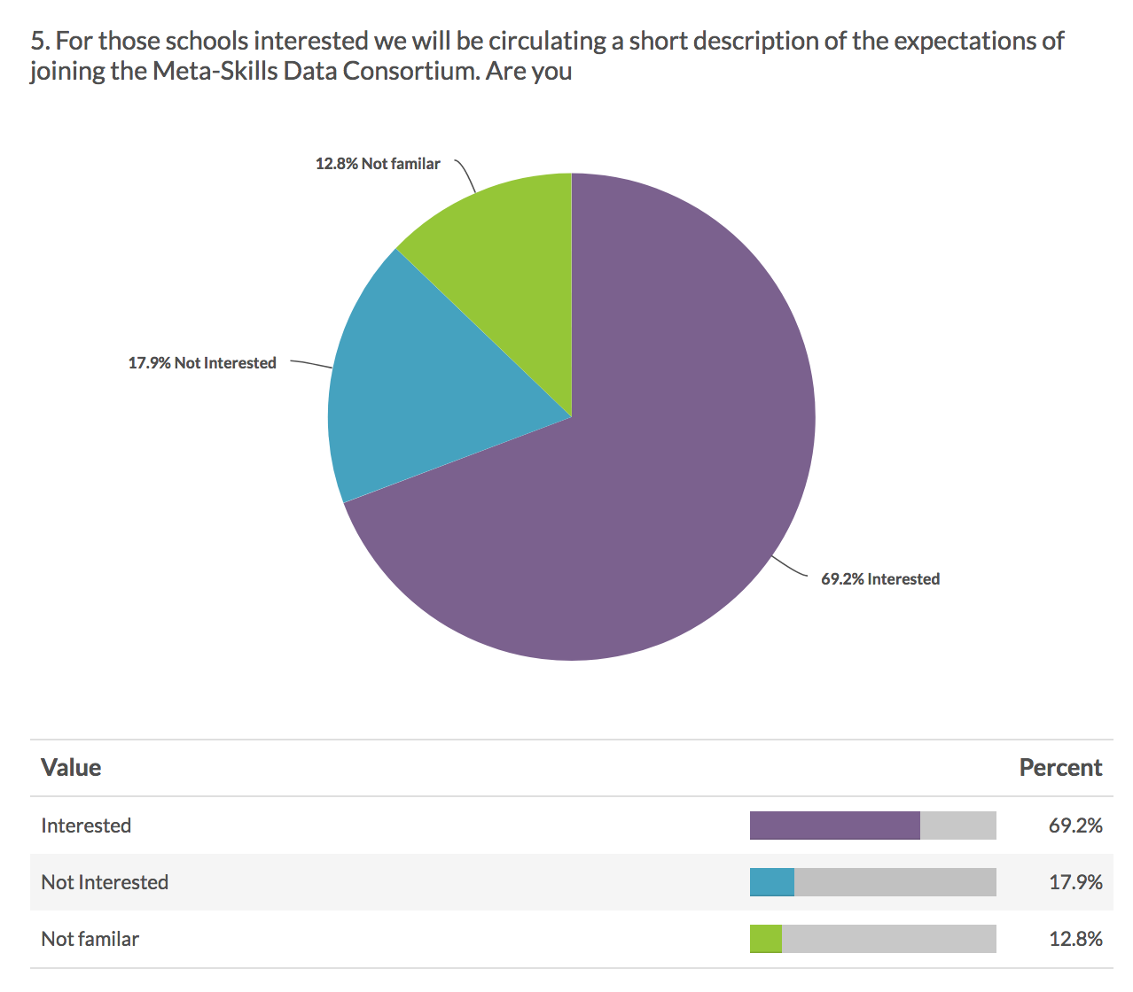

Deborah Dowling, Assistant Head of Academics at Chadwick School CA:

"The Meta-Skills Data Consortium is definitely an initiative Chadwick is keen to participate in. It fits very well with our educational priorities, and we are excited to be involved."

